Data annotation

# 1 - Download locally folder for your respective ID

Go to this google drive and download the folder based on these IDs

| ID | Name |
| --- | --- |
| 1 | Allen Nicholas |
| 2 | Pellett Cameron |
| 3 | Meressa Abrha Megos |
| 4 | Barasso Caterina |
| 5 | Sara López Fernández |
| 6 | Anna Shcherbacheva |
| 7 | Merry R. D. Crowson |
| 8 | Maria Moan |
| 9 | Jääskeläinen Johanna |
| 10 | Tomas Quiñones |
| 11 | Shaohui Zhang |
| 12 | Camilo Chiang |
| 13 | Yasaman Amini |
| 14 | Nicholas Pontone |
| 15 | Kennedy Kanja |
| 16 | Raul De Paula Pires |
| 17 | Rorai Pereira Martins Neto |
| 18 | Samantha Wittke |
| 19 | Ahmad Aqeel |
| 20 | Jaime Candelas Bielza |
| 21 |  |
| 22 |  |

# 2 - Open Qgis and drag and drop all of the .tif files in Qgis

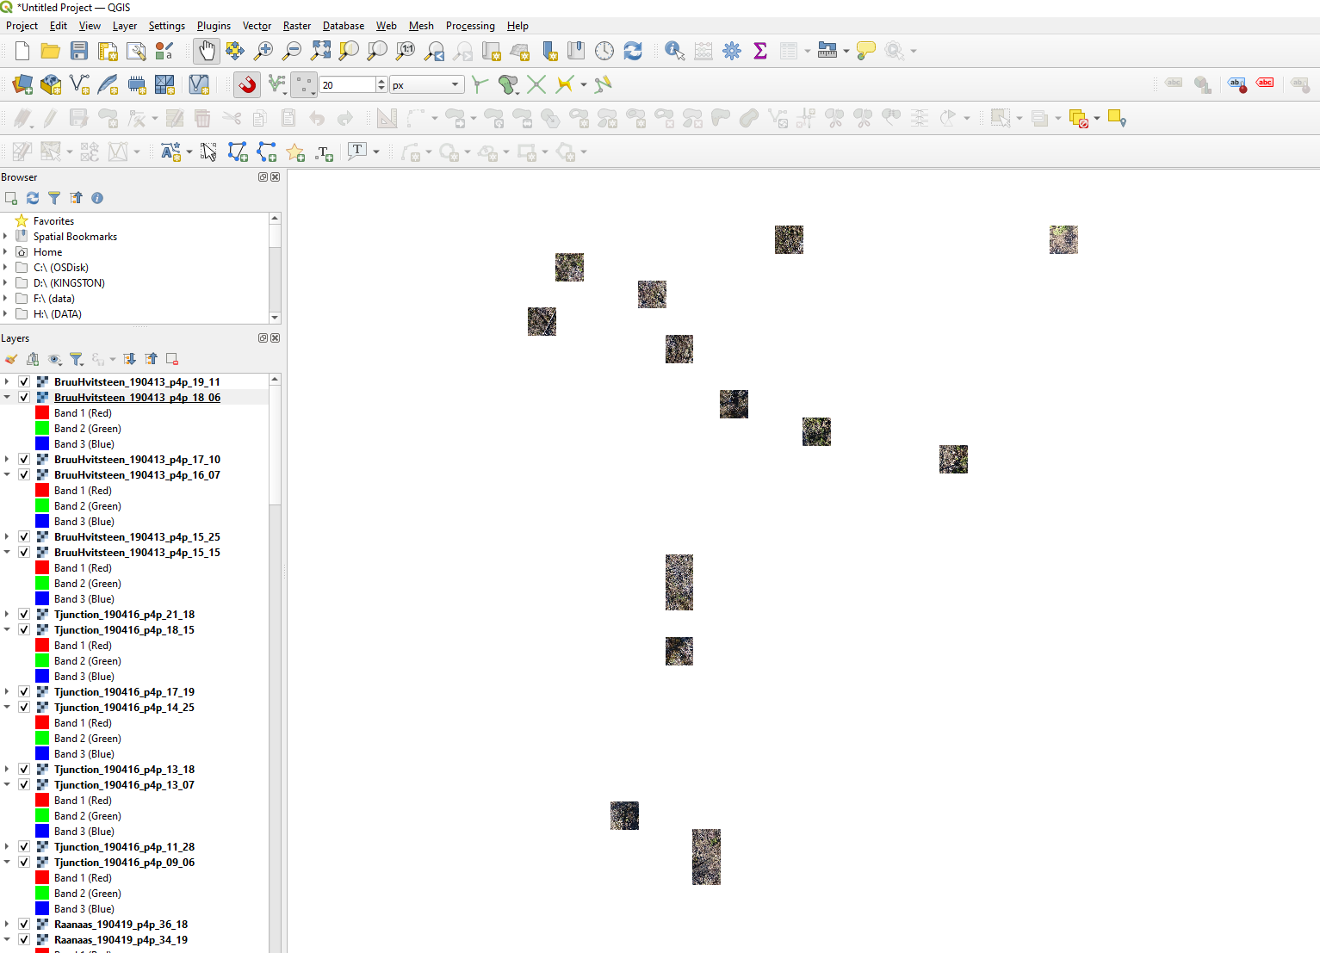

# 3 - create new polygon layer in your local environment

* Go to Layer > create layer > new shapefile layer

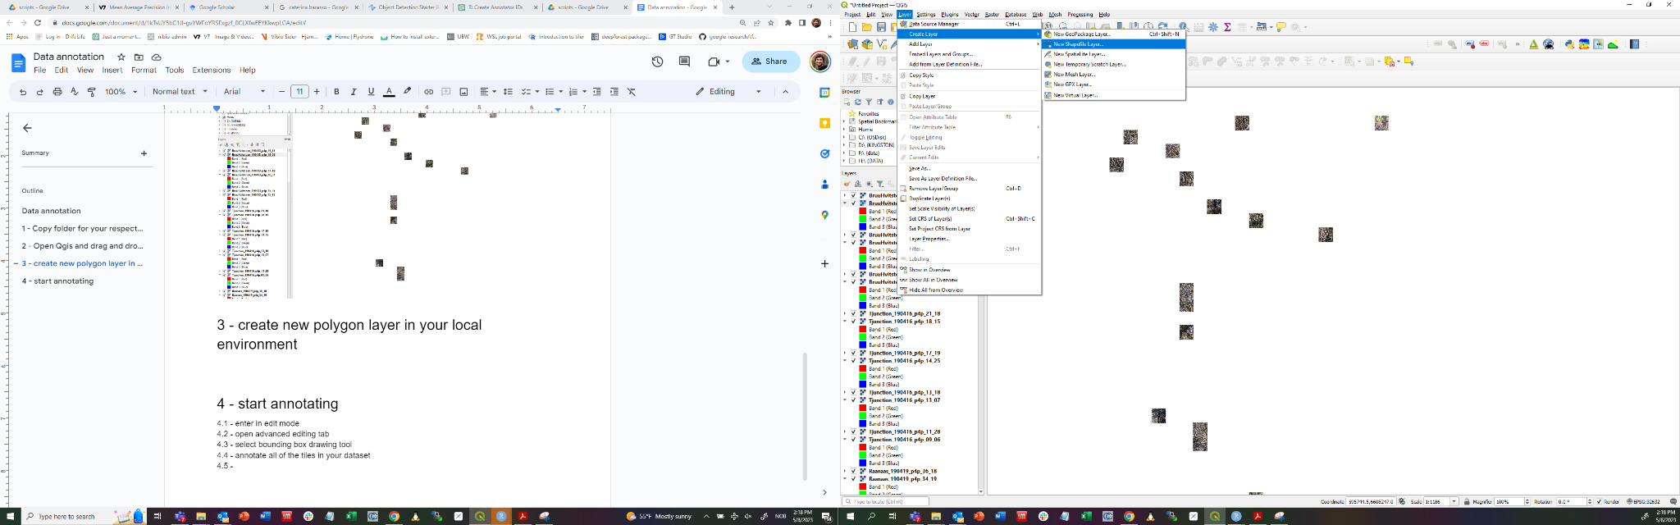

* Modify the following:
  + Filename= …/your_dir/annotations_24.shp (make sure to write the correct ID corresponding to you)
  + Geometry type = Polygon
  + Coord. Ref. system= EPSG 25832
  + Create new string field called class with length of 15 (this will be used to define the tree class)

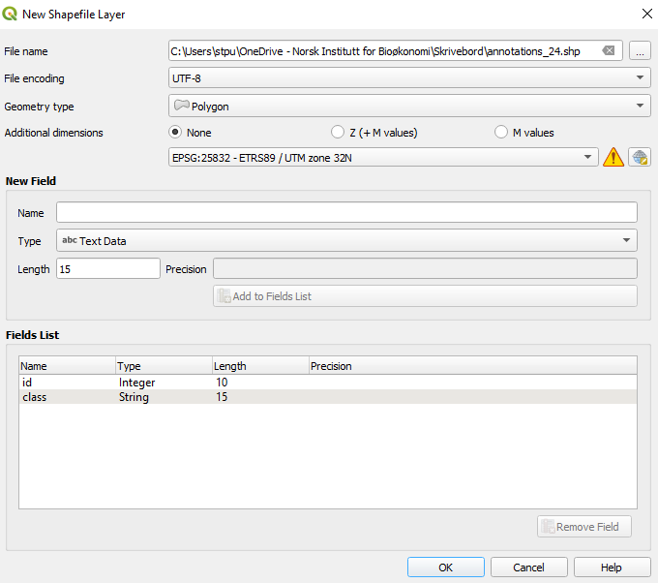

# 4 - start annotating

4.1 - in view > toolbars enable the digitizing toolbar and shape digitizing toolbar

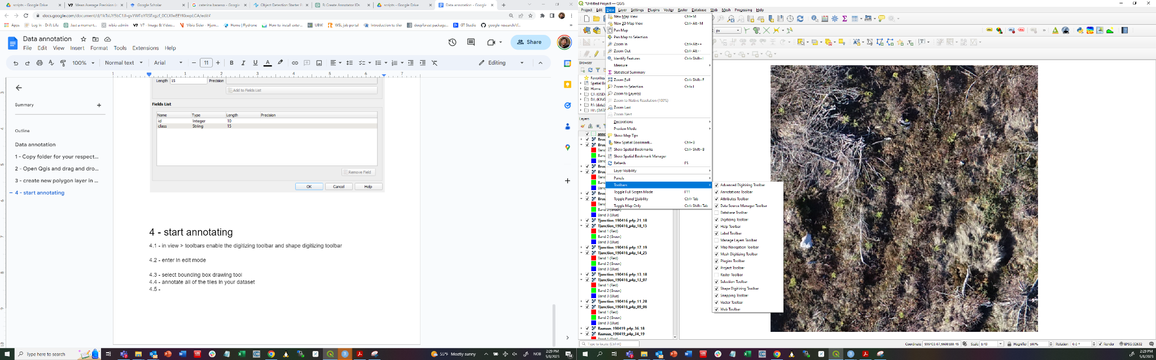

4.2 - enter in edit mode



4.3 - select add rectangle from extent in shape digitizing toolbar(bounding box drawing tool) 

4.4 - Go to first tile (right click on the tile and select zoom to layer) and annotate all of the visible trees in the tile

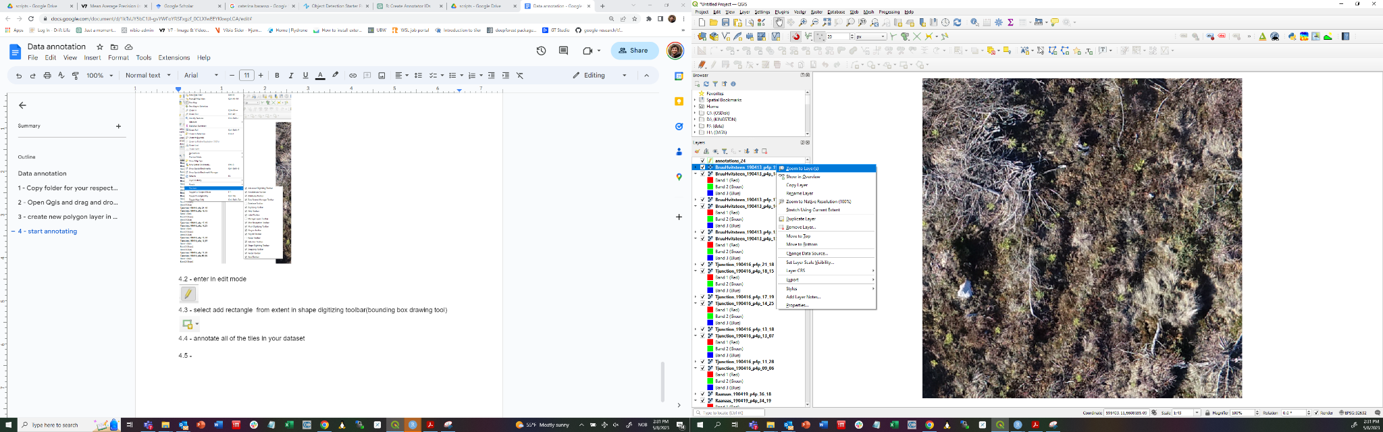

4.5 - Proceed with the next tile

# 5 - save annotations

# 6 - import annotations and tiles in google drive

Drag and drop the annotation shapefile and the image tiles to the data > annotated_data > train > your ID folder

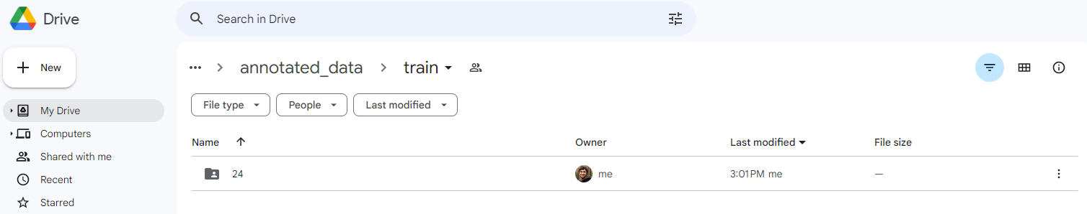

# 7 - go to the [next colab notebook](https://colab.research.google.com/drive/1x_crZDfatp6ak22Zmi26mNTLaLblPbtU) for converting the UTM annotations to YOLO format